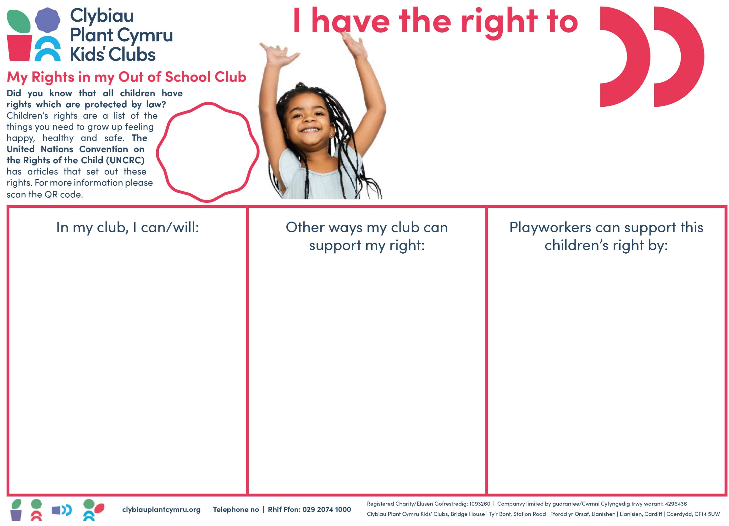
v
relax and play; explore my own culture through play; try new and exciting opportunities.



Article 31

- Play freely, when and how I want.
- Rest and chill-out.
- Try a range of new and exciting play opportunities.

- Reflect my Rights.
- Ensure our Play Policy reflects children’s Right to play and freely engage in cultural and novel experiences & opportunities.
- Understand the benefits of play and work within the Playwork Principles.
- Provide play opportunities that promote different cultures, ideas and interests.

- Understand my right to play and other rights.
- Ensure that all staff are Playwork qualified.
- Promote Article 31 and advocate for play at the setting - to parents’ staff and community members.


Guidance for Playworkers
- Watch the videos about Children’s Rights with the children, on the Children’s Commissioner for Wales website (QR code above).
- Talk with children
- Allow them to add their ideas in the box/try other participation methods Click here for ideas.

Consider how you can add what the children tell you into your policies. Relevant policies for this right include (Clybiau Plant Cymru Kids’ Clubs ’members can access template policies in ‘Stepping Out’):
- Play Policy
- Risky Play
- Children’s Participation Policy
- Equal Opportunities/Inclusion Policy

The development of this right within your setting could result in a child focused guidance through a poster, series of photographs or video and form part of a children’s handbook/resource.

Further Information:
- Article 31 Poster - https://ipaworld.org/resources/for-children/colouring-pages/
- United Nations Convention on the Rights of the Child (UNCRC) Symbols Resource
- 10 Ways the child’s voice can shape the setting, Clybiau Plant Cymru Kids’ Clubs
- General Comment 17 - This is Me video - https://www.youtube.com/watch?v=5tjRPWPhIfA
Did you know?
General Comments strengthen each Article (right), raising its importance and increasing accountability among countries that have signed up to the Convention. Those linked to Article 31 are:
- General Comment 17 - Reinforces the importance of children having opportunity to engage in play that promotes and supports their own culture and ensures that have access to novel experiences and opportunities, such as the Arts, theatre & sport etc.
- General Comment 25 - Ensures that children are not exposed to inappropriate content online and their details are not shared with 3rd parties - and puts an onus on Playworkers to educate children about the dangers online and gives children responsibilities, i.e. regular screen breaks

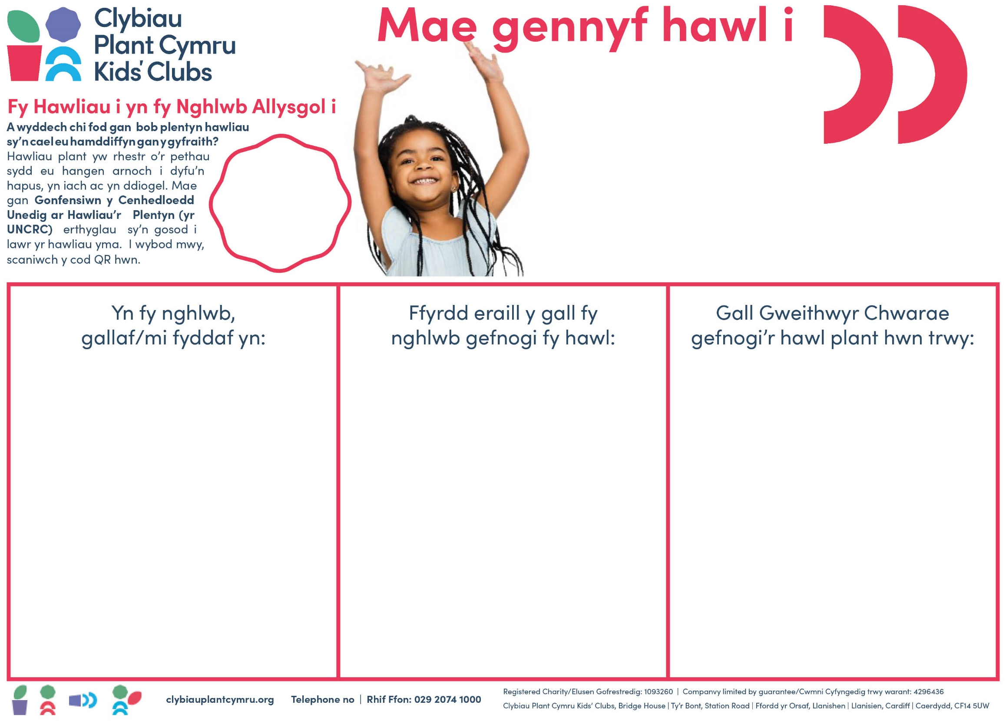
ymlacio a chwarae; archwilio fy niwylliant fy hunan drwy chwarae; rhoi cynnig ar gyfleoedd newydd a diddorol
Erthygl 31
- Sicrhau bod pob polisi a gweithdrefn yn adlewyrchu fy Hawliau.
- Sicrhau bod ein Polisi Chwarae’n adlewyrchu Hawl plant i chwarae ac ymgysylltu’n rhydd mewn profiadau a chyfleodd diwylliannol a Newydd.
- Deall buddion chwarae, a gweithio o fewn yr Egwyddorion Gwaith Chwarae.
- Darparu cyfleoedd chwarae sy’n hyrwyddo gwahanol ddiwylliannau, syniadau a diddordebau.

- Deall fy hawl i chwarae a hawliau eraill.
- Gwneud yn sicr bod yr holl staff wedi cymhwyso mewn Gwaith Chwarae.
- Hyrwyddo Erthygl 31 ac eiriol dros chwarae yn y lleoliad - i rieni, staff ac aelodau’r gymuned.

- Chwarae’n rhydd, pan a sut yr wyf i eisiau.
- Gorffwys ac ymlacio.
- Rhoi cynnig ar amrediad o gyfleoedd chwarae newydd a chyffrous.


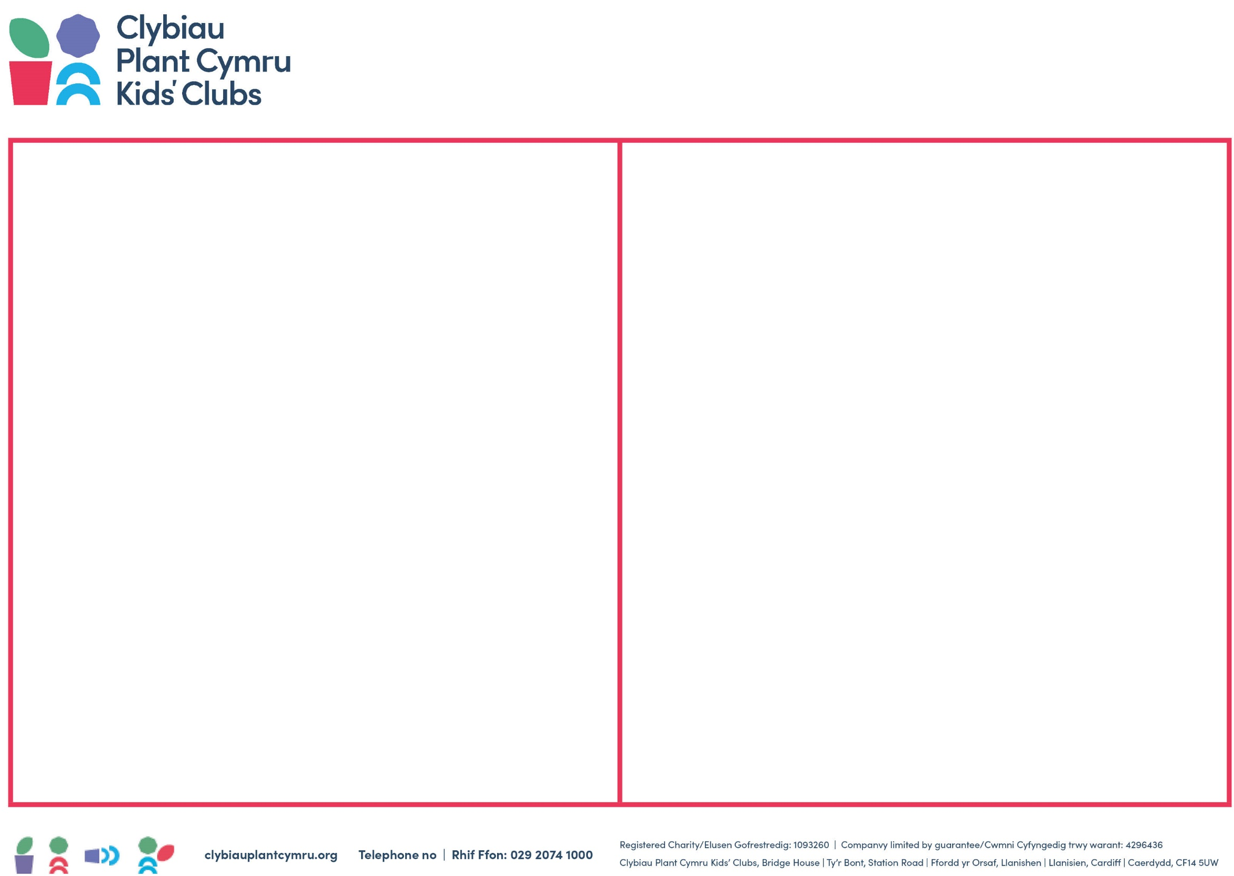
Gwybodaeth Bellach:
- Poster Erthygl 31 - https://ipaworld.org/resources/for-children/colouring-pages/
- Adnodd Symbolau: Confensiwn y Cenhedloedd Unedig ar Hawliau’r Plentyn (UNCRC)
- 10 Ffordd y gall llais y plentyn lunio’r lleoliad, Clybiau Plant Cymru Kids’ Clubs
- Sylw Cyffredinol 17 – Fideo Dyma Fi - https://www.youtube.com/watch?v=5tjRPWPhIfA

A wyddech chi?
Mae Sylwadau Cyffredinol yn cryfhau pob Erthygl (neu hawl), gan gynyddu ei bwysigrwydd a chynyddu atebolrwydd gwledydd sydd wedi cofrestru gyda’r Confensiwn. Y rhai sy’n gysylltiedig ag Erthygl 31:
- Sylw Cyffredinol 17 – Y mae’n atgyfnerthu pwysigrwydd bod plant yn cael cyfle i gymryd rhan mewn chwarae sy’n hyrwyddo ac yn cefnogi eu diwylliant eu hunain ac sy’n sicrhau bod gan blant fynediad at brofiadau a chyfleoedd newydd megis y Celfyddydau, y theatr a chwaraeon ayyb.
- Sylw Cyfredinol 25 – Y mae’n sicrhau nad yw plant yn dod yn agored i ddeunydd amhriodol ar-lein ac nad yw eu manylion yn cael eu rhannu ag unrhyw 3^{ydd} parti; y mae’n rhoi cyfrifoldeb ar Weithwyr Chwarae i addysgu plant am beryglon ar-lein h.y. toriadau sgrin rheolaidd.

Arweiniad i Weithwyr Chwarae

- Gwyliwch y fideos am Hawilau Plant gyda’r plant, ar wefan Comisiynydd Plant Cymru (gweler y cod QR uchod).
- Siaradwch â’r plant
- Gadewch iddyn nhw ychwanegu eu syniadau yn y bocws/rhowch gynnig ar ddulliau cyfranogi eraill. Cliciwch yma am syniadau.

Ystyriwch sut y gallwch roi'r hyn y mae'r plant yn ei ddweud wrthych yn eich polisïau. Mae'r polisïau perthnasol i’r hawl hon yn cynnwys (Gall aelodau o Clybiau Plant Cymru Kids’ gyrchu polisïau templed yn ‘Camu Allan’):
- Polisi Chwarae
- Risg mewn Chwarae
- Polisi Cyfranogaeth Plant
- Polsi Cyfle Cyfartal/Cynhwysiant

Gall datblygu’r hawl hon yn eich lleoliad arwain at arweiniad a fydd wedi ei ffocysu ar y plentyn, drwy gyfrwng poster, cyfres o ffotograffau neu fideo, a ffurfio rhan o lawlyfr/adnodd plentyn.

